Code Smells

Comments

Illustrating code snippet

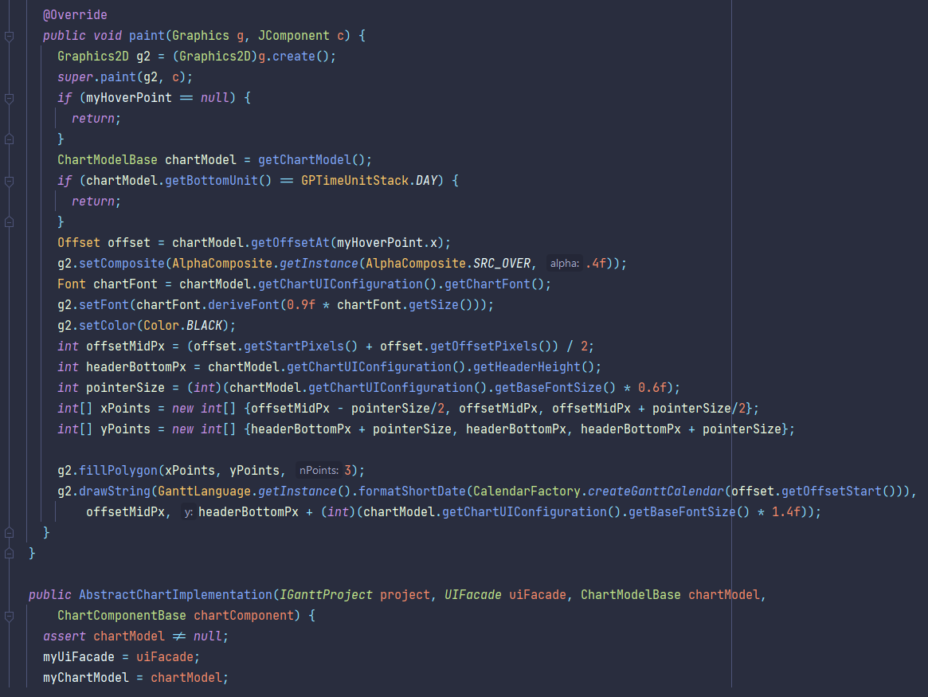

Class location
/ganttproject/src/main/java/net/sourceforge/ganttproject/AbstractChartImplementation.java

Explanation
The class is missing any form of comments describing the functionality of its methods, making it harder to understand.

Refactoring proposal
Add descriptive enough comments to make it easier to read the code.

Large class

Illustrating code snippet

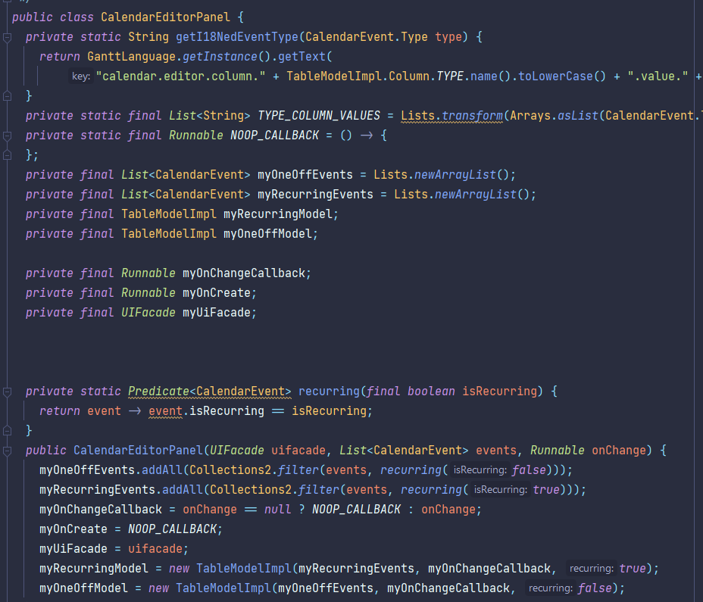

Class location
/ganttproject/src/main/java/net/sourceforge/ganttproject/calendar/CalendarEditorPanel.java

Explanation
This class is too large, indicating it has too many responsibilities and less organization.

Refactoring proposal
Creating more specific classes that take care of smaller sets of actions the original class was responsible for.

Shotgun Surgery

Illustrating code snippet
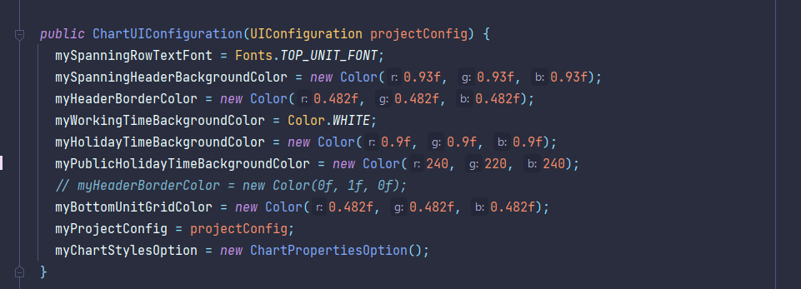

Class location
/ganttproject/src/main/java/net/sourceforge/ganttproject/chart/ChartUIConfiguration.java

Explanation
Changing colors in any part of the code may be harder than intended given that there is no general definition for such.

Refactoring proposal
Create constants responsible for holding each color used throughout the code.

